Creativity Tour 2024 Packing List

Part of the fun of a big trip is planning out what you will take and what you will carry it in. Because traveling overseas is full of surprises and unexpected events it is important to bring things that are both lightweight and flexible. Here are some suggestions.

The Not-So-Big Suitcase
Make sure it is on wheels with a pull-up handle. The expandable zipper type is a helpful feature. The less you bring, the better off you’ll be later. Can you pick it up and carry it or go up a few stairs—after it is packed? One checked bag is included for overseas flights.

Start out light! We will have to lift our luggage quickly onto trains between cities. We will work as a team to get us all on board. Smaller luggage fits better on the storage racks by our seats so we can keep an eye on it.

Carry-On Luggage – Keep it Simple
Bring a mid-sized bag (backpack or tote) for daytime sightseeing. Only carry onto the plane more one small bag (typical carry-on luggage size or smaller) plus a purse / messenger bag-sized item.

*If you require prescription medications, take double what you need and place half in your carry on and half in your checked luggage. If one set gets lost, or we have delays coming home, you’ll be happy to have a complete back-up.

Tourist Supplies
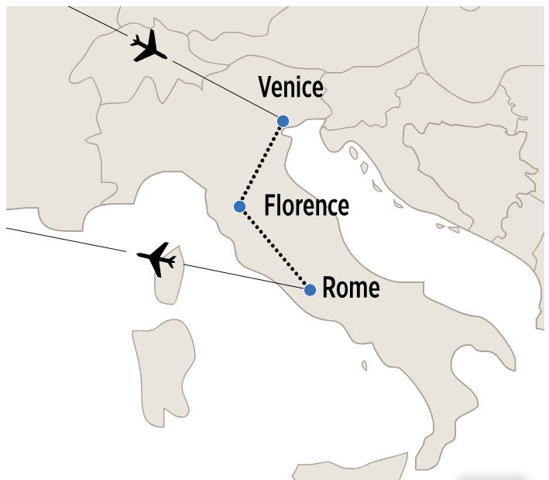
- Camera, extra data cards, extra batteries
- Reusable shopping bag
- Optional face masks, hand sanitizer
- An open mind, ready for adventure

Average Temperatures for June/July:
Venice: Daytime: 83 Night: 67
Florence: Daytime: 82 Night: 70
Rome: Daytime: 88 Night: 70

Walking Tour Supplies
- Comfortable walking shoes/sneakers
- Water bottle
- Sun hat & Sunscreen

Art Making Supplies:
A sketchbook or art journal, travel size
Favorite pens/pencils, sharpener, tiny scissors in checked luggage
We will supply additional art materials along the way.
What else will I need?
Use the itinerary to help choose clothes for each day.
Avoid overly casual items (such as sleepwear as outer wear, sweatpants).

Lightweight mix & match clothes
Walking shoes (break them in before you go, think urban hiking on cobble stones)
1 slightly dressy outfit or shirt
Light jacket
Travel size toiletries
Entertainment for the flights / train (music, paperback book)
Plastic bags for wet/dirty clothes
Sunblock & sunglasses
Very tiny umbrella, pocket rain poncho (or just buy one there if needed)
Inflatable neck pillow for sleeping on the long flights
First aid items, your medications (Dramamine if needed)
Recharger cord for phone/camera

Optional:
There may be an opportunity to swim. During our free day in Rome some of us plan to go to Ostia Antica followed by a nearby beach. If interested, bring swimwear or water-friendly clothes and flip-flops or water shoes.

Cell Phones:
Check with your cell phone company to find out about international rate plans available to you. Even text messages can cost several dollars apiece overseas. Make a plan for your cell phone for texts, calls, and data. Italy has internet cafes and the hotels will offer Wifi, so you can keep in touch online, too.

Electricity: Europe uses the round, 2-pronged plug. Power is 220 (double the U.S.) so you will need a power converter as well. Many devices have a converter box built into the plug. Read the fine print carefully. Select electronic devices with care. Ask yourself: How heavy is it? What if I drop it? Do I truly need it for this week?

If it would break your heart to lose it, leave it at home.



